|  |
| --- |
| **Naïve Bayes Classifier** |



|  |  |
| --- | --- |
| **Title: ML** | **Advisor: KiKi** |
| **Name: Seungsoo Lee** | **Date: 21-01-2020** |

**Index**

1. **Training Set**
2. **Model / Naïve Base Model**
3. **Testing Set**

**1. Training Set**

|  |  |  |  |  |  |
| --- | --- | --- | --- | --- | --- |
| User | Gender | Lover | GPA | Laptop | Destination |
| u1 | M | N | 3 | LG | US |
| u2 | M | Y | 4 | Apple | AU |
| u3 | M | N | 3 | LG | AU |
| u4 | M | N | 3 | Samsung | US |
| u5 | F | N | 4 | LG | AU |
| u6 | M | N | 3 | Apple | US |
| u7 | F | N | 3 | Samsung | AU |
| u8 | F | Y | 3 | Samsung | AU |
| u9 | F | N | 3 | LG | AU |
| u10 | M | N | 3 | LG | AU |
| u11 | M | N | 3 | Apple | US |
| u12 | M | N | 4 | Samsung | US |
| u13 | M | N | 3 | LG | AU |

**2. Model / Naïve Base Model**

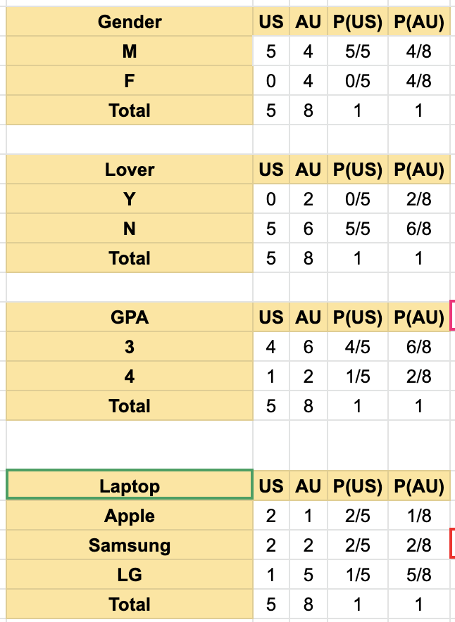

**3. Testing Set**

